HIERARCHY UPDATE
-AUTONOA: APPRAISAL WEBSITE

**Manager’s now have the opportunity to update their organizational hierarchy while entering employees’ annual TAPES appraisal. (This option will be available on other appraisal forms soon.)

Click: Update Hierarchy Here

- -Select- the current Supervisor from the drop down list
- Click: Update Hierarchy

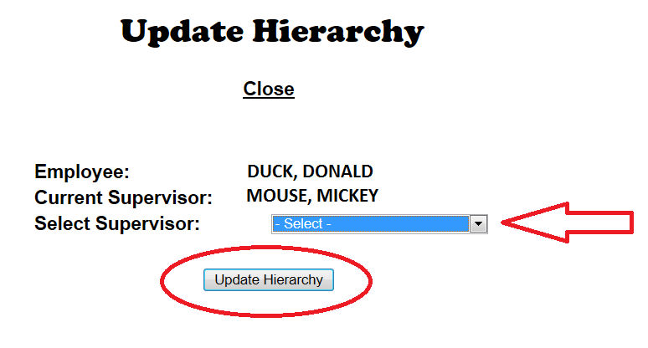
AUTONOA: AutoNOA will update the hierarchy; the update will be visible in the CPOL/Portal within 24-48hours. Hierarchy can also still be updated directly in CPOL/Portal.

